

2nd HIGH SCHOOL OF DRAPETSONA
COMENIUS 2010 – 2012

THE ANCIENT GREEK COLONIES IN BLACK SEA REGION

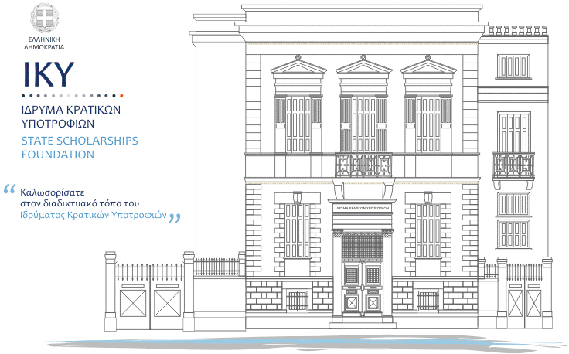
Sumary

The colonization of the Black Sea was initiated from the second half of the 7th century. BC until the early Classical period. Metropolis of the majority of the colonies on the Black Sea was Miletus, which established important cities such as Sinope, Amisus, Istria and Olbia. In the colonization of the region Megara, participated to a lesser degree which founded Heraclea Pontica and Mesimvria, Teos, Mytilene, etc. Colonies based their economy on fishing, on cultivation of cereals and the exploitation of rich reserves of Pontus in timber and minerals. They were developed in major comercial centers while, in most cases, they maintained ecxelent relations with the inhabitants of the region.
Date: second half 7th century BC- late fifth century. BC
Geographical Identification: Black Sea

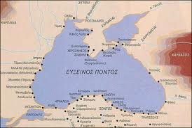

1. Introduction

It is possible to assert for certain – based on the archeological data from Georgia and the information about Pontus in ancient Greek sources - that Greeks knew the areas of the Black Sea since the 8th century B.C.The colonization – however – started since the 2nd half of 7th century B.C. during the second period of the great colonial wave of the Greeks in the Archaistic period, which followed the colonization of the areas in South Italy, Sicily, Western Mediterranean, Adriatic and north coastline of Aegean Sea. The penetration of the Greeks in the areas of Pontus is mainly associated with the colonialist efforts of Miletus. Stravon-the geographer - stresses that the town was famous for the big number of colonies made in the areas of the Black Sea, and Propontida. Megara, Teos and some other towns participated in the colonization of the area. The massive colonization of Pontus takes place in the 6th centuty B.C. and is completed about in the end of the Archaistic period. The town of Athens, only, settled entitled to a shave at western coastline of the Black Sea.
2. Colonization “Models”

Two colonization models have been noticed in the areas of the Black Sea: the Ionic (Militos,Teos, etc) and the Doric (Megara,Iraklia in Pontus).
The first model was peaceful and adaptable with the native financial or political conditions; the second one exploited the native populations directly. At the beginning, the natives were part of the inhabitant of the greek colonies and until the end of the Archaistic period, the relations among themselves were peaceful.However, this has changed since the beginning of the 5th century B.C., when local kingdoms started to be founded in Thrace, Scythia, Kolchida and Paflagonia under the Persian control. In the 5th century B.C., the Bosporus Kingdom was founded by the greek towns in the peninsulas Kerch and Taman, to encounter the laying out of Skythes. The greek towns at the Thrace coastline of the Black Sea lost their freedom because the Kingdom of Odysseus consolidated in the area. Anyway, the 4th century was a period of prosperity for both towns and kingdoms; this is the reason why the infiltrating of the greek element was allowed in the interior of areas in Pontus. The oracle of Apollo at Didima, worked as a common devotional place for the colonies in Militos. The towns in Pontus worshiped Apollo as their patron. Apollo Leader was worshiped at Phasi in Kolchida, whereas Demetra was worshiped by the greek communities in the wider area.

3. Colonization of Propondida

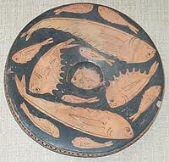

Before deciding to make colonies in the Black Sea, the Greeks looked into the potentials of entering the Black Sea of areas in Propontida. During the 1st half of the 7th century B.C. colonists from Militos, Erythres and Paros founded Pario, at southern coastline of Propontida- in the eastern interior of Ellispontos.
More eastern from Pario, the inhabitants of Militos established the rural community of Kyzikos and more south –western from this Abidos. The inhabitants of Phokea founded more north –eastern in the same area Lampsakos. The inhabitants of Megara founded Chalkidona and Astakos in the Asian coastline of Propontida and Silymbria in the northern coastline. Seventeen years later, according to Herodotus, they set up the town of Byzantium, opposite Chalkidona, in an extremely profitable position.

4. Colonization of Pontus

4.1 First period of colonization of Pontus (2nd half of 7th century B.C.)

In the 7th century B.C. and mainly during the last third, a small number of colonies was made in northern west and southern coastline of the Black Sea.
Sinopi, a colony of Miletus, almost in the centre of northern coastline of Asia Minor is placed in the 7th century B.C.
Trabzon was founded by citizens in Sinopi as a colony. Kotiora and Kerassounta were colonies at the north coastline of Asia Minor; Tios and Sesamos were colonies of Miletus for sure.
In the end of the 7th century B.C. , inhabitants in Miletus founded Istria, on the western coastline of the Black Sea, in today’s Romania; Orgami on Danube delta, whereas on north coastline, on the island Berezan, in today’s Ukraine, commerce was settled, which grew up to a colony next century. However, recent ceramic finds from Bezeran and Istria hint the participation of colonists from other towns as well, like Samos, Chios, Efessos and Smyrna probably. In 610 B.C. Miletus founded the town of Apollonia in Thrace in today’s Bulgaria.
Sozopolis is a small ancient town, 30 km south from Burgas in Bulgaria. Sozopolis is the oldest town of the Bulgarian coastline on the Black Sea. First settlement at these places is dated at least since the 1st half of the 6th century B.C., since Apollonia was founded by inhabitants of Miletus, leaded by Anaximandros. Underwater explorations in the area of the harbor brought to light remnants of houses, ceramic earthen utensils, tools of wood and stone from the copper Age. A lot of anchors have been discovered at the bay of Sozopolis from 2nd to 1st century B.C. which is a proof of active shipping since ancient times. The town developed as a commercial and naval centre. It kept on intimate political and trading relations with big towns in Greece: Militus, Athens, Korinthos, Pontiki Iraklia and the islands: Rhodes, Chios, Lesbos e.t.c. The town symbol- the anchor- present at all coins, made in Apollonia since the 6th century B.C. is a proof of the importance of trading. The rich town became an important cultural centre. At that time it was called Apollonia Magna.
Olvia Pontiki, (also called Voristhenis), was an ancient greek colony at the north-west coastline on the Black Sea. The town was a colony, founded by inhabitants of Militos and was built during the 2nd greek colonization, possibly in 7th century B.C.
The town had its own coin, very early, designed as the shape of an arrow; this proves that the colony had been stabilized during the 6th century B.C., having developed trading relations with neighboring peoples. There was a temple, developed to Apollo Delphinio in Olvia. The inhabitants also worshiped Achilles as a God. Olvia was besieged by Zopyriona, Great Alexander’s general in 331 B.C.; he didn’t manage, however, to conquer the town. The town starts declining, in the third century B.C. First it was conquered by King Skilouros of Skythia and then it was comprised to the kingdom of Pontus, of King Mithridatis. The town was successively attacked first by Getes and then by Gothi in the 3rd century B.C. As a result it was complety abandoned till the middle of the 4th century.

4.2 Second period of colonization of Pontus (first half of 6th century B.C)

Up to 560 B.C. the following towns are founded by Miletus, Tomis in the west coastline of Pontus in today’s Romania, Olvia-ancient Varisthenis in the north near Bevezan, Pantikapaio, Nymphaio, Theodosia,, Myrmykio, Tyritaki, in the area of Kimmerius Vosporos in the north-eastern of the Black Sea and Hermonassa, Kipi and Patrefs on the coastline of the Asian Vosporos. Colonists from Mytilini took part in founding Hermonassa as well.

4.3 Third period of colonization of Pontus (560 -530 B.C.)

Other towns, also, except from Militos, took part in colonizing Pontus. Inhabitants of Megara and Viotia – in around 560-550 B.C. founded Iraklia, in the south coastline of Pontus.
The town grew up to a big trading centre, where vine-growing was developed. In the end of 5th century B.C. the town expanded its domination to the half west of the northern coastline of Asia Minor and then issued a coin.
Around 560 B.C. inhabitants of Militos founded Odyssos, in the western coastline of the Black Sea and in 550 B.C. the towns Tyras and Nikonion were founded in the wider area of Olvia. Amissos may have been founded- in the middle of the 6th century B.C.-in the coastline on the east of Sinopi. In 542 B.C. Teos founded Phanagoria, in the area of Kimmerios Vosporos , on the European Vosporos Acra, Porthmefs and Illurato. At this period inhabitants of Miletus founded in the area of Kolchida the towns Phasi, Gyino and Dioskouriada.

5. Colonies in Pontus during the classical period

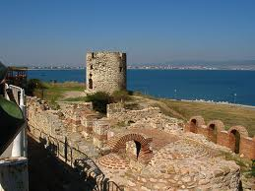

During the classical years a few-relatively colonies were founded, which-however- grew up to important centers of the area.According to Herodotus, in 493 B.C. inhabitants of Megara settled in the coastline of Thrace and founded Mesimvria. In the beginning of the 5th century B.C. inhabitants of Iraklia in Pontos founded Kallati on the northern coastline of today’s Romania and in the end of the 5th century the Peninsula Tavriki in Krimaia.
6. Reasons of colonization
The reasons of colonization of the Black Sea were not exclusively rural (new-fit for cultivation-land) or trading (wheat, slaves). Furthermore, they were not only related with the necessity to find raw materials (especially metals and wood) or with the growth of population in towns – and the resulting problem of “narrow space (stenochoria)” in other words the lack of land. In many cases, reasons absolutely political are added to the above mentioned reasons of colonization.

7. Productive sectors of the colonies
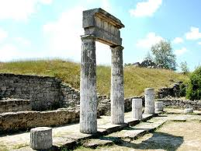
Economy in Greek colonies was mainly based on fishing, agriculture, small industries and trade. The basic products- imported from local communities- were metals, domestic animals, leathers and slaves, while products of Attika were very popular to colonists from areas out of Pontus. Production of local handicraft products started from the middle of 6th century B.C. Ceramic furnaces, found at Istria, Nymfeo, Pantikapaio, Fanagoria, Gorgippia, Sinopi, and the Peninsula Tavriki testify a remarkable production of ceramic products from 6th to 2nd century B.C. like earthen statuettes, oil lamps, wearing weights, household items and amphoras. Metalwork was produced in Pantikapeo, Nympheo, Fanagoria, Berezan and goldsmithery developed especially after the 4th century B.C. when native population asked for jewels, utensils and weapons from precious metals a lot of times.

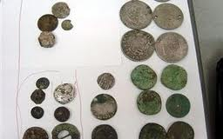

The Sozopol (Bulgarian: Созопол, ancient name Apollonia Pontiki) is a small, ancient city, 30km south of Burgas in Bulgaria. The Sozopol is the oldest city in the Bulgarian Black Sea Coast. The first installation of these parts dates back at least the first half of the 6th century, as Apollonia (as was the name previously) established Milesians led by Anaximander (611-547 BC approx.) The underwater explorations in the harbor area have revealed remains of dwellings, ceramic pottery, stone and wooden tools from the Bronze Age.

In the Bay of Sozopol have been discovered many anchors from the 2nd-1st century BC, proof of active shipping since ancient times.

The city developed as a commercial and shipping center. It maintained close political and commercial relations with major cities of Greece - Miletus, Athens, Corinth, Heraclea Pontica and islands Rhodes, Chios, Lesbos, etc. The commercial impact on the Thracian territories was based on a treaty with the leaders of Odrissianou Kingdom from the 5th century B.C.

The city's symbol - the anchor, is present in all currencies, cut in Apollonia from the 6th century B.C. is testament to the importance of trade. The rich town soon became an important cultural center. At that time they called Apollonia Magna.

The ancient images and exquisite wooden shrines are noteworthy achievement of the skill of the time. The architecture of the houses in the old city of the Renaissance period makes it a unique place to visit today.

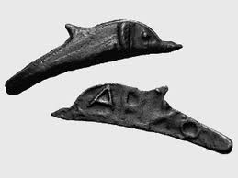

The Olbia Pontiki (Vorysthenis was called) was an ancient Greek colony on the northwestern coast of the Black Sea. The city was a colony of Miletus, built during the second Greek colonization probably in the 7th century B.C. According to Herodotus and other ancient writers was at the estuary of the River Bug ancient Development Ministry while according to some ancient writers was further east at the estuary of the Dnieper to the ancient Greeks called Vorystheni. Settlers as Eusebius informs us that Caesarea, seems originally settled in the island opposite to the present Berezan, but gradually passed towards the estuary of the Bug, the founding Olbia. The city was cut early on coins made in the shape of the arrow which indicates that the colony had stabilized during the 6th century B.C. and had developed trade relations with neighboring nations. Olbia in a temple dedicated to Apollo Delphinium. Residents outside the Apollo and Achilles worshiped as a god. Herodotus visited the city during the 5th century B.C. and has preserved a description of the city. At that time the currency had made Olbia shaped dolphins bounced off the water. The coins-dolphins quickly replaced the previous coins with an arrow.

The Olbia was besieged in 331 B.C. by the general of Alexander the Great Zopyriona, but he was not able to conquer the city. In the 3rd century BC the city begins to decline. Originally occupied by the king of Scythia Skilouro and then included in the kingdom of Pontus King Mithridates. In the 3rd century A.D. the city received successive attacks of Geton initially and then the Goths, leading to mid-fourth century completely abandoned.

